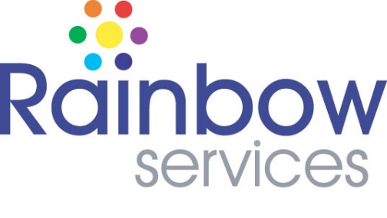

Senior Officer – Youth Project Job Description

Rainbow Services is a Harlow based charity. We have 21 full and part-time employees, and our mission is to alleviate the effects of poverty and deprivation. We have been successfully doing this through our wide range of community-based projects for nearly 25 years.

We are now looking for a Project Manager to oversee our Youth Project.

If you have a passion for delivering high quality community-based projects that make a real difference to young people’s lives. If you have experience working with young people in a fast-paced environment where no two days are the same. If you have carpentry experience or are a multi-skilled tradesperson/tutor, we would love to hear from you!

Job Title: Senior Officer

Responsible to: Project Lead

Job Purpose: To oversee the coordination of community projects (in this case Our Youth Project) in line with our mission, by managing teams which may include, Project Officers, and Assistants - as well as Volunteers. The role will involve delivering practical carpentry skills in our workshop and theory sessions in a classroom setting.

Location: The Rainbow Centre, 2 Wych Elm, Harlow, CM20 1QP

Hours: Full time (37 hrs per week) over 5 days.

Starting salary: £33, 958.60 per annum

Contract: Permanent

Responsibilities and Duties

- Oversee the coordination of projects (in this case our Youth project) across Rainbow Service to ensure successful delivery to a high standard in order to achieve our charitable aims.
- Line manage staff in project teams and the wider Rainbow Services office as necessary.
- Establish a positive and interactive relationship with all young people referred to the Youth Project and those met when carrying out outreach and engagement work.
- Support young people to re-engage with learning and develop stronger connections within their community.
- To develop and maintain links and relationships with schools/colleges, community groups, other youth organisations, statutory services, youth justice services, funders and potential employers.
- Plan, prepare and deliver accredited (currently Gateway) carpentry qualifications in the Rainbow Services’ carpentry workshop.
- To be the Internal Quality Assurance lead for the Youth Project
- Ensure the effective safeguarding of all young people supervised by you or the Youth Project team.
- To gather and record monitoring and evaluation data which demonstrates the impact of the Youth Project.
- Ensure all health and safety requirements are met within the carpentry workshop.
- To contribute to social media campaigns across all platforms by providing content to colleagues responsible for our social media.
- Establish a positive “can do” work culture, including continuous improvement and personal development.
- Continuously evaluate and monitor the success of projects to develop and improve them.
- Co-ordinate and oversee the management of volunteers, ensuring all relevant checks and training are up to date.
- Represent Rainbow Services, the Youth Project and the wider voluntary sector at external meetings.
- Participate in the staff appraisal system.
- Adhere to Rainbow Services policies, procedures and organisational quality standards.
- Any other tasks as may be required from time to time.

Qualifications and Key Skills
(For a full list see person specification)

- Experience working with young people from a wide variety of backgrounds
- Qualified carpenter and/or a multi skilled tradesperson (or equivalent experience)
- GSCE English and Maths, or equivalent relevant experience.
- Holds an IQA qualification or is willing to begin working towards one immediately upon appointment.
- Experience in delivering successful projects.
- Excellent communication skills, able to converse and work with a wide range of stakeholders at all levels.
- An understanding and empathy for challenges around poverty and deprivation.
- Excellent written skills for writing reports, press releases, social media, etc.
- Leadership experience, or a willingness to develop.
- Excellent team working skills, but also an ability to take ownership of work and get the job done.

Employee Benefits

- 26 days annual leave plus bank holidays.
- Free parking.
- Comprehensive employee assistance programme.
- Free apprenticeships and training – and time provided to complete these.
- A real sense of reward and working for good with a friendly, supportive team.

