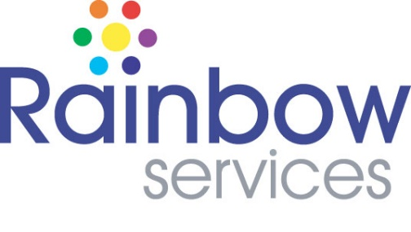

Pedal Power Project Mechanic Job Description

Rainbow Services is a Harlow based charity. We have 21 full and part-time employees, and our mission is to alleviate the effects of poverty and deprivation. We have been successfully doing this through our wide range of community-based projects for nearly 25 years.

We are now looking for a new Mechanic as we expand our services.

If you have a passion for delivering high quality community-based projects that make a real difference to people’s lives. If you can work flexibly in a fast-paced environment where no two days are the same. If you like working in a supportive team environment, and take ownership of your work, lead people to achieve great outcomes, and are an innovative problem solver, we would love to hear from you!

Job Title: Pedal Power Project Mechanic

Responsible to: Project Lead

Job Purpose: As cycle mechanic you will be responsible for building a range of bikes, carrying out general maintenance repairs, the servicing of our fleet of bikes and deliver a range of bike repair sessions including maintenance workshops. The "Essex Pedal Power" initiative in Harlow aims to encourage cycling in deprived areas of the town, or communities within in it, by providing free bikes, cycling training, and support services to residents.

Location: The Rainbow Centre, 2 Wych Elm, Harlow, CM20 1QP and community settings.

Hours: Part time (9 hrs per week)

Starting salary: £15 an Hour

Contract: 12-month contract

Responsibilities and Duties
- Build a range of bikes to cater for the local communities that we serve.
- Carry out general repairs and the servicing of our bike fleet using an agreed schedule as approved by the Project Co-ordinator. This will include bike repairs being carried out in our workshop and at other community venues.
- Identify, order and fit a range of bike parts that are needed to ensure the maintenance, or enhancement, of our bike fleet within an agreed budget.
- To work in an entrepreneurial way with the local community to deliver Cycle Maintenance Workshops and Dr. Bike training sessions.
- To maintain an electronic inventory of our bike stock and an electronic servicing record for our bike fleet.
- To work with the Manager to maintain the brand and integrity of our projects.
- Any other reasonable tasks as required by the Manager.

Duties may vary from time to time without changing the general character of the post or the level of responsibility.

Qualifications and Key Skills

- Educated to GCSE level, with GSCE English and Maths, or equivalent relevant experience.
- Cytech or City and Guild Cycle Mechanic qualified, at least at Level 1 (preferably at Level 2).
- Confident to be customer facing to support the needs of the local communities.
- Ideally experience of working or volunteering in the voluntary sector.
- Good computer skills, knowledge of Microsoft Office is desirable.
- Excellent communication skills, able to converse and work with a wide range of stakeholders.
- Strong organisational skills to support the management of multiple aspects of the programme, including logistics and participant data.
- Experience in community development or working with marginalised populations.
- Understanding of health and wellbeing promotion principles.
- An understanding and empathy for challenges around poverty and deprivation.
- Excellent team working skills, but also an ability to take ownership of work and get the
job done.
- Excellent problem solving skills.
- A good understanding of and commitment to equal opportunities and the implications for this role.

Employee Benefits

- 26 days annual leave plus bank holidays (pro rata).
- Free parking.
- Comprehensive employee assistance programme.
- Dog-friendly office.
- Free apprenticeships and training – and time provided to complete these.
- A real sense of reward and working for good with a friendly, supportive team.

